Vernacular Names: Beach Gardenia | Scientific Name: Guettarda speciosa L.
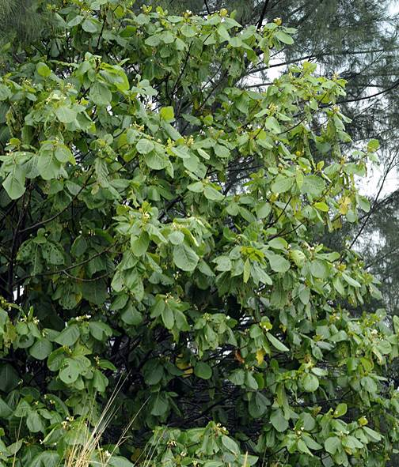 | 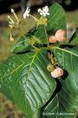  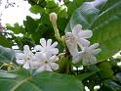
Full tree form | Details of leaf, flower, & fruit
Native or Introduced: Native

Description: Small to large tree, dense canopy of large, prominently-veined, oval leaves, that are velvety to the touch due to the very fine hairs on the under-surface. Flowers white, long tubular corolla and sweet-scented at night, hence the name Beach Gardenia. Fruit small, round. The long corolla of the white flowers, and the cream-coloured fruits identify this tree against others with similar form and leaves.

Habitat: Especially frequent as a fringe tree along the shoreline just above the hide tide line, and behind any Scaevola fringe. It can also be found well inland.

Human uses: The large leaves were used in various ways by the indigenous people of northern Australia; they could hold food, and when heated, they were given to relieve headaches and aches in limbs. The stems could be used to make Macassan pipes. The flowers were used to scent coconut oil on the Cook Islands, and the wood for dwellings and canoes.

Significance: Small tree, quite fast growing. Along with Hernandia and Cordia this is one of the most widespread and typical of Chagos trees. Provides good shade for other species.

Propagation: Seed, slow developing. Saplings from already germinated seeds beneath trees.

